**1.Write C++ program to create dynamic allocation for array using char datatype**

#include<iostream>

using namespace std;

int main()

int n,i;

cout<<"enter size of an array:";

cin>>n;

char *p=new char[n];

cout<<"enter the values:\n";

for(int i=0;i<n;i++)

{

cin>>*(p+i);

}

cout<<"the values are:"<<endl;

for(int i=0;i<n;i++)

{

cout<<*(p+i)<<endl;

}

return 0;

}

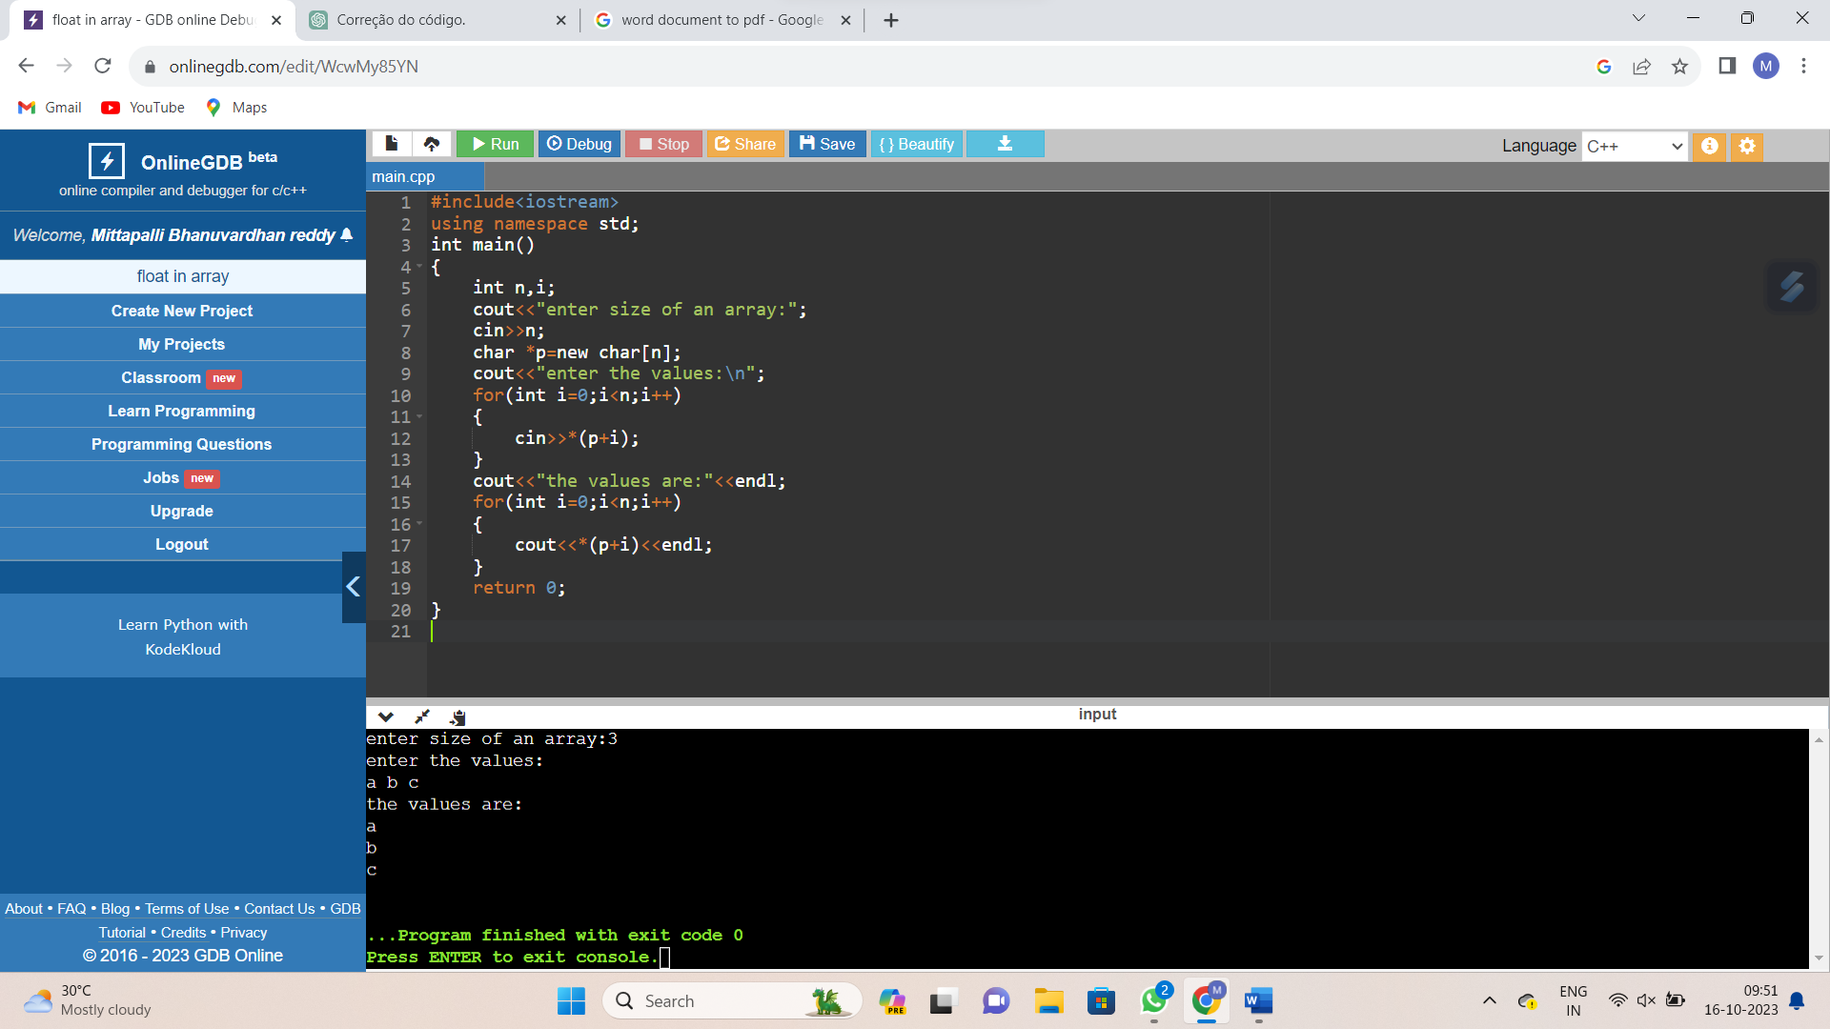

**2.Write C++ program to create dynamic allocation for array using float datatype**

#include<iostream>

using namespace std;

int main()

{

int n;

cout<<"enter size of an array:";

cin>>n;

float *p=new float[n];

cout<<"enter the values:";

for(int i=0;i<n;i++)

{

cin>>*(p+i);

}

cout<<"the values are:"<<endl;

for(int i=0;i<n;i++)

{

cout<<*(p+i)<<"\n";

}

return 0;

}

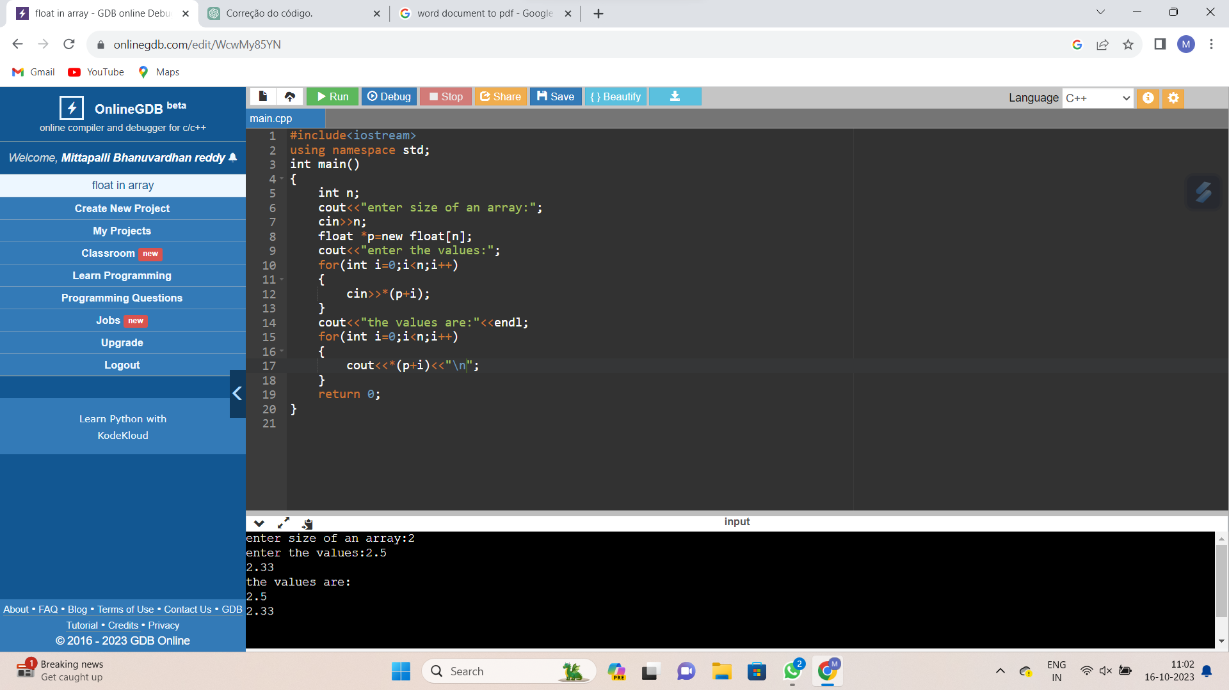

**3.Write C++ program to create dynamic allocation for array using double datatype.**

#include<iostream>

using namespace std;

int main()

{

int n;

cout<<"enter size of an array:";

cin>>n;

double *p=new double[n];

cout<<"enter the values:";

for(int i=0;i<n;i++)

{

cin>>*(p+i);

}

cout<<"the values are:"<<endl;

for(int i=0;i<n;i++)

{

cout<<*(p+i)<<"\n";

}

return 0;

}

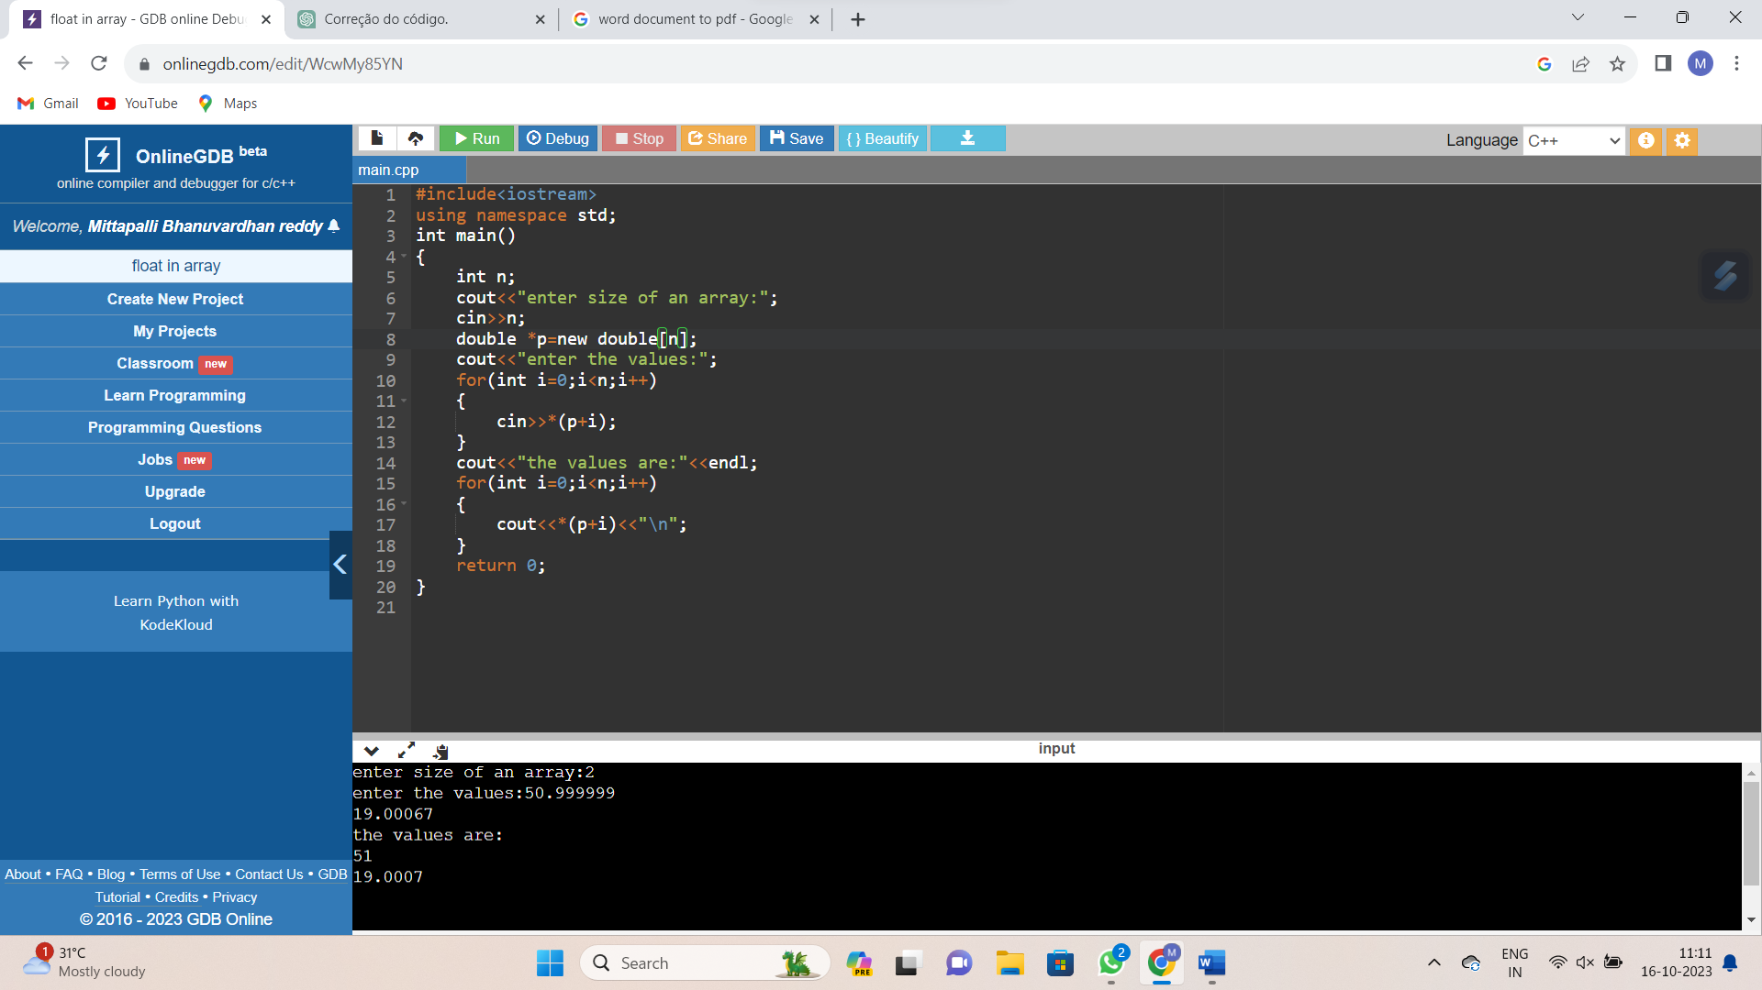

**4.Write C++ program to create dynamic allocation for array using int datatype**

#include<iostream>

using namespace std;

int main()

{

int n;

cout<<"enter size of an array:";

cin>>n;

int *p=new int[n];

cout<<"enter the values:";

for(int i=0;i<n;i++)

{

cin>>*(p+i);

}

cout<<"the values are:"<<endl;

for(int i=0;i<n;i++)

{

cout<<*(p+i)<<"\n";

}

return 0;

}

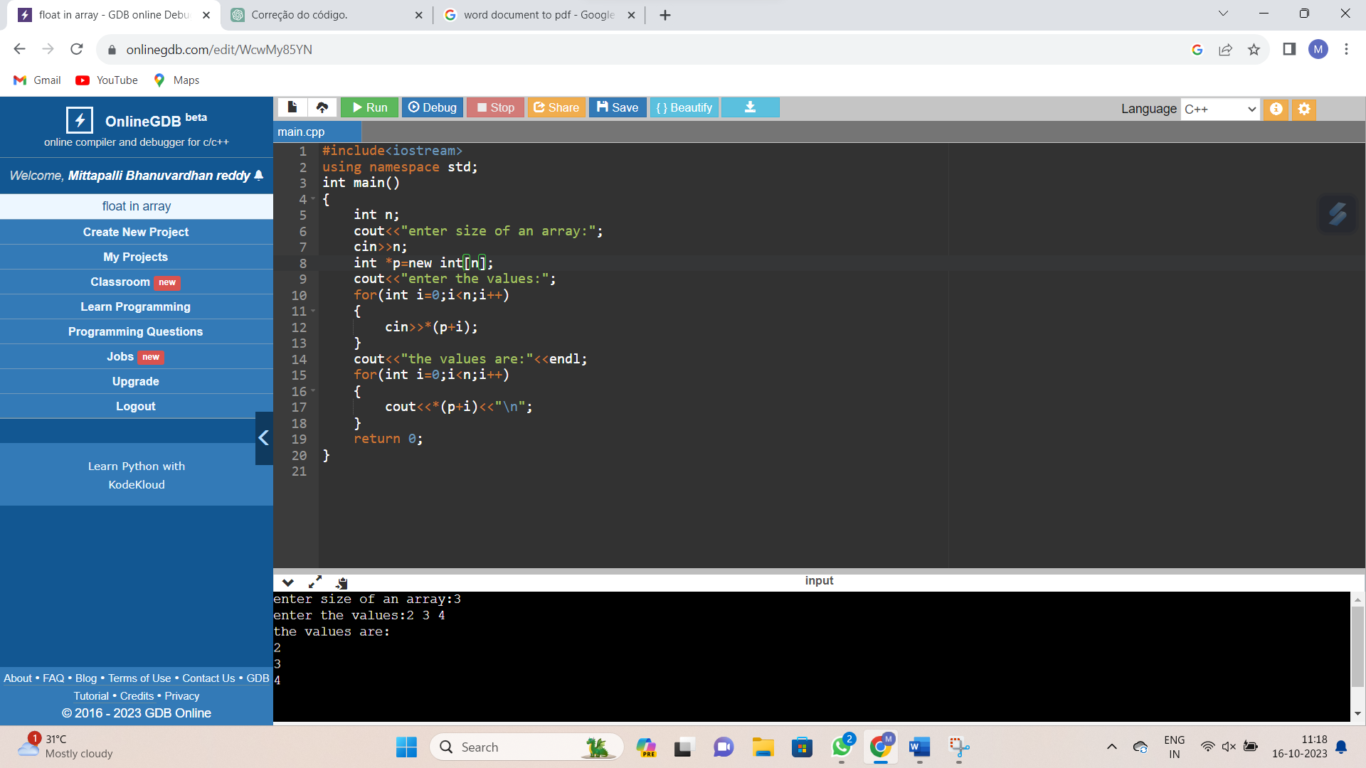

**5.Write C++ program to create dynamic memory allocation for object**

#include<iostream>

using namespace std;

class ME

{

public:

int a;

ME()

{

a=436;

}

~ME()

{

cout<<"obj.destructor";

}

void print()

{

cout<<a<<"\n";

}

};

int main()

{

ME *A1=new ME;

A1->print();

delete A1;

return 0;

}

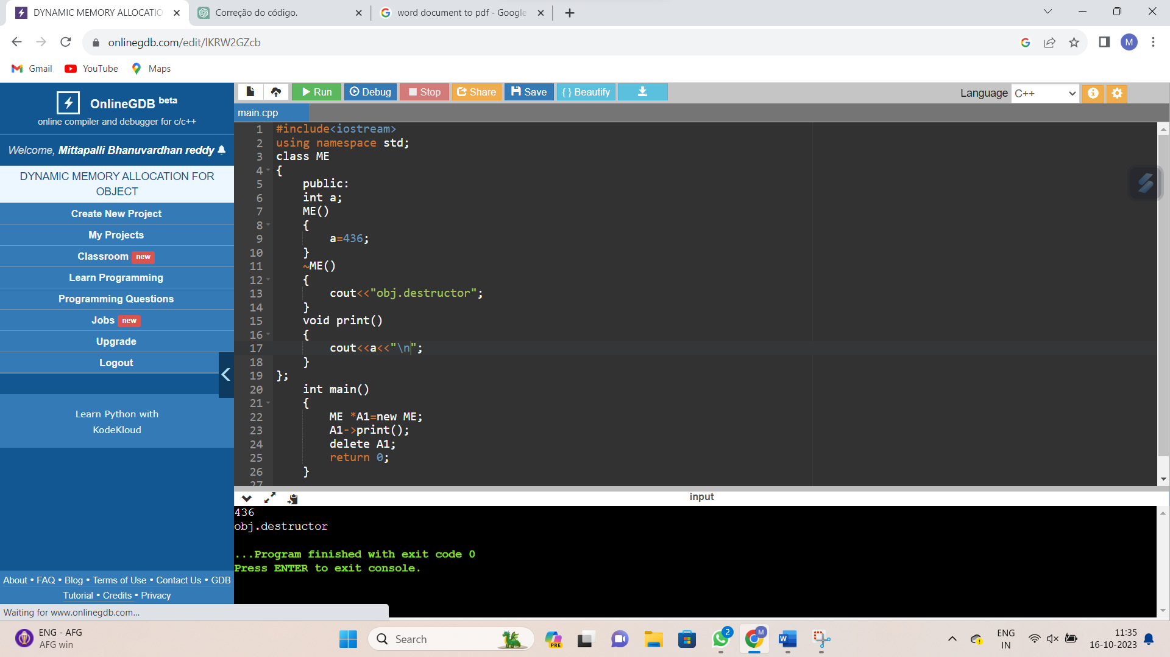

**6.Write C++ program to create static memory allocation for array.**

#include<iostream>

using namespace std;

class A

{

public:

int a;

A()

{

a=436;

}

~A()

{

cout<<"obj.destructor"<<"\n";

}

void print()

{

cout<<a<<"\n";

}

};

int main()

{

int i,n;

A A1[3];

for(i=0;i<3;i++)

A1[i].print();

return 0;

}



**7.Write C++ program to create static memory allocation for array.**

#include<iostream>

using namespace std;

class A

{

public:

int a;

A()

{

a=436;

}

~A()

{

cout<<"obj.destructor"<<"\n";

}

void print()

{

cout<<a<<"\n";

}

};

int main()

{

int i,n=5;

A *p = new A[n];

for(int i=0;i<n;i++)

{

(p+i)->print();

}

delete []p;

return 0;

}

